ONLINE EXAMINATION SCHEDULER

TEAM MEMBERS:
- Abhishek Gupta ( POD Leader )
- Debopom Kumar ( POD Member )
- Ajay Shaw ( POD Member )
- Debojit Chakraborty ( POD Member )
- Preeti Jha ( POD Member )

CONCEPTUAL DESIGN

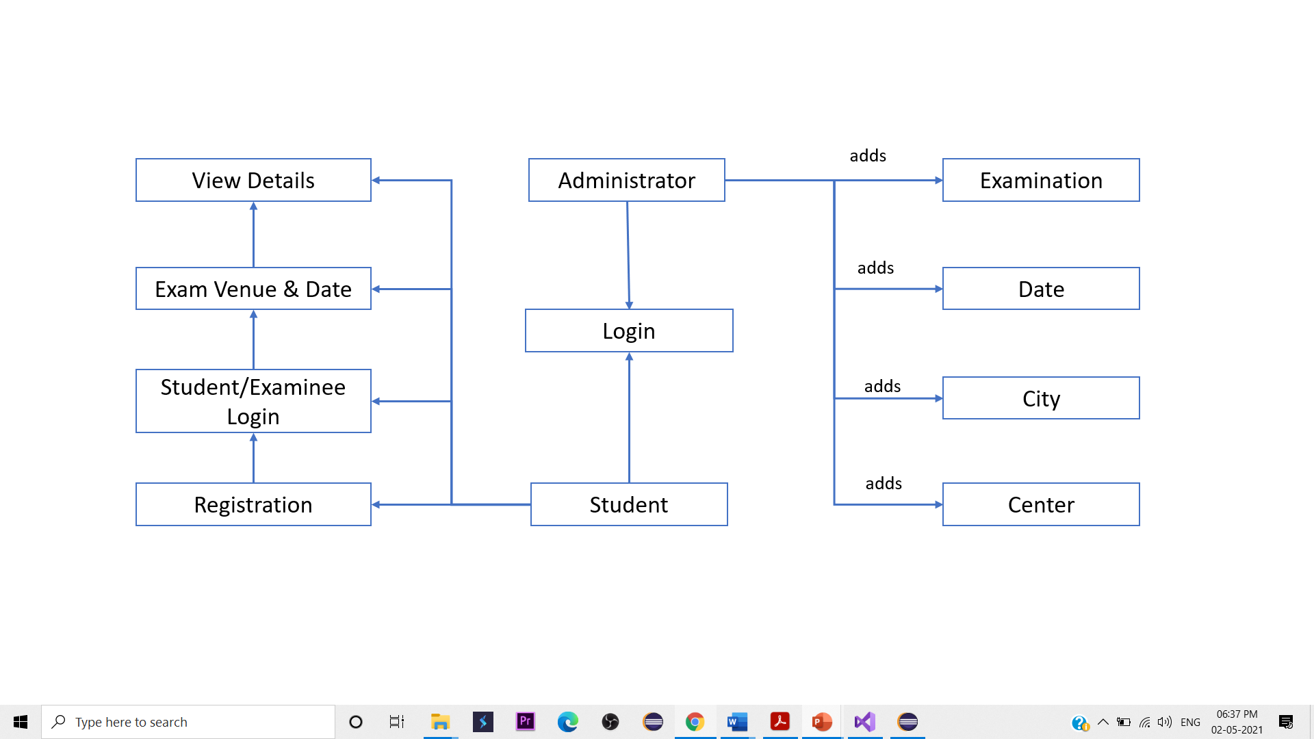

CLASS DIAGRAM

Administrator
public class admin_login
{
admin_id – string
admin_password – string
}

public class exam_add

public class addcenter

public class datefixlogin

public class admin_datafix

public class addcity
Student/Examinee
public class registration

public class examlogin

public class fixingdate

public class Display

DATABASE DESIGN

